bdt fcyklsmaz16()

bat funpos16()

Id tabadr

bgt fsmazcan16()

Id prihlasen

bmt nadres16()

bgtc jenkod()

bgtb otockod()

Id avy

bgta tabkod()

bgut umazzesou10()

id smyc

bct smycka3()

Id mezera

Id koltext

tmenu16()

id mosexy tet

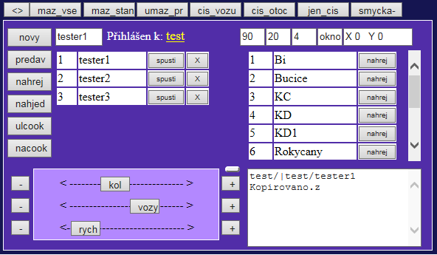

id adr tat

id okno tbt

Id ctabadr

inputb1 maztext16()

bbpt vicvuz13()

bpt vickol13()

abat, bbat, cbat fposir13()

Id vozy

cbnt menrych13()

abnt menvuz13()

Id rych

Id kol

bnt menkol13()

bvt nahkuk42()

bbt fnahpredvym16()

bet padres16()

but kuk42()

bzt Autpred11()

Id texta16

dbpt vicrych13()

Id jmtext

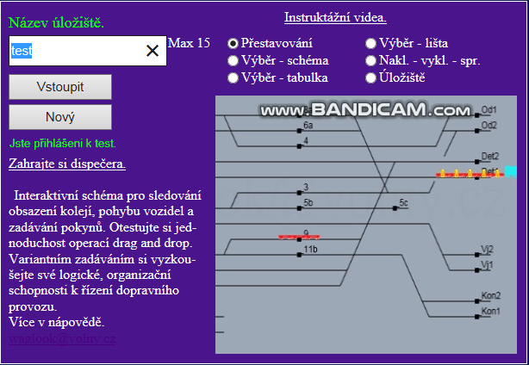

byt prihlas42()

cyt novyadr42()

Id vystuprih

prihlasaf16()